

**School of Computer Science and Engineering**

**CZ3003 Software Systems Analysis & Design**

**Lab Group: TR2**

**Team Name: Iced Milo**

**Team Members:**

**Benjamin Tan Jun Qi (U1922188H)**

**Joei Yan Zhu Yi (U1921976A)**

**Jonathan Chang Ji Ming (U1923331A)**

**Renganathan Ramasamy (U1922494L)**

**Tan Huiying Valerie (U1821571G)**

**Date submitted:** **10 October 2022**

**Revision History**

| **Name** | **Date** | **Reason for Changes** | **Version** |
| --- | --- | --- | --- |
| Iced Milo | 10/10/22 | Initial Document | 1.0 |

# Contributors

| **Name** | **Email** |
| --- | --- |
| Tan Huiying Valerie | vtan027@e.ntu.edu.sg |
| Joei Yan Zhu Yi | jyan005@e.ntu.edu.sg |
| Renganathan Ramasamy | re0001my@e.ntu.edu.sg |
| Benjamin Tan Jun Qi | c190179@e.ntu.edu.sg |
| Jonathan Chang Ji Ming | jchang015@e.ntu.edu.sg |

# Introduction

## Purpose

This document lays out the development plan for our game: MathGenius, an application engineered and developed by Iced Milo. The intended readers of this document are current and future developers that might undertake this project. The plan will include a summary of our projected system’s functionality, static and dynamic models that our game would follow, and data-flow diagrams.

## Document Conventions

Our document features the usage of Arial font size 12 for the text bodies, Times New Roman size 14 or 18 for titles and subheadings.

## Intended Audience and Reading Suggestions

This document is intended for any project manager, developer, software tester, or user that is involved in the design, development and testing of MathGenius.

This is the intended reading suggestion:

1. Introduction
2. Component Diagram
3. Communication Diagrams
4. ER Diagram

## Product Scope

MathGenius aims to become an interactive platform and game that aids and enhances the learning experience for the subject of Mathematics. Currently, the project is being developed for students in Nanyang Technological University to use, and the Professors or Teaching Assistants would take on the role of Administrators of the game.

**1. Component Diagram (Static Model)**

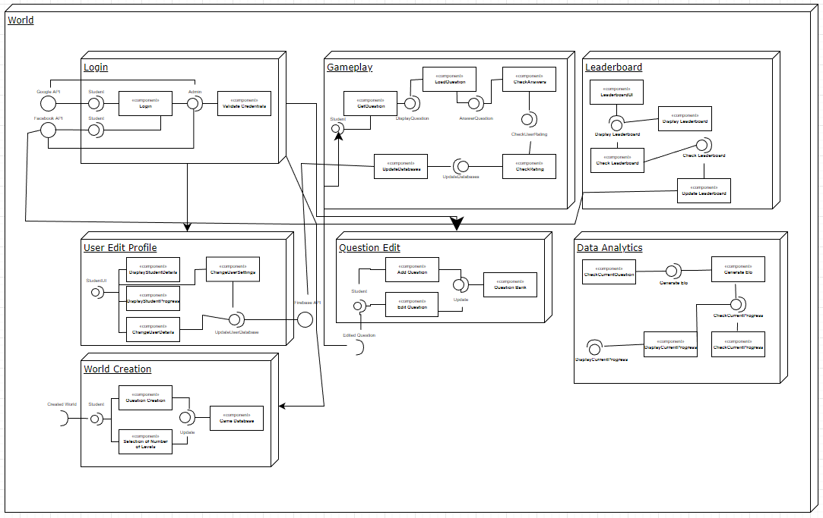

**Note: A high resolution version of this diagram can be found in our SVN submission.**

**2. Communication Diagrams (Dynamic Model)**

**Administrator Communication:**

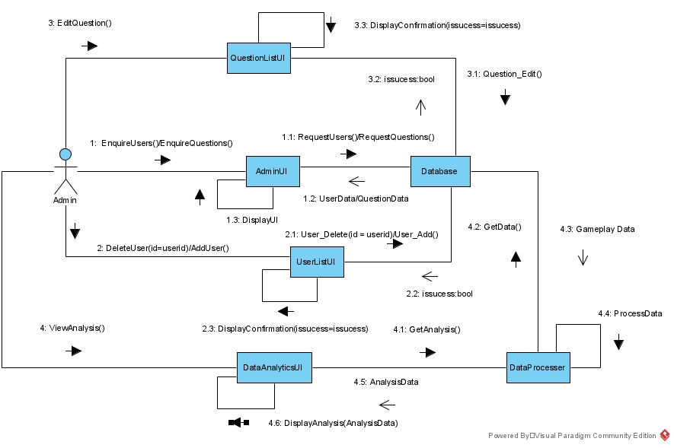

**Student Communication:**

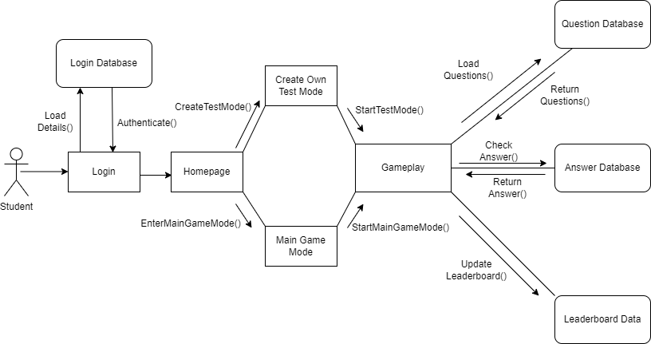

**Note: A high resolution version of these diagrams can be found in our SVN submission.**

**3. ER Diagrams (Data Persistence Design)**

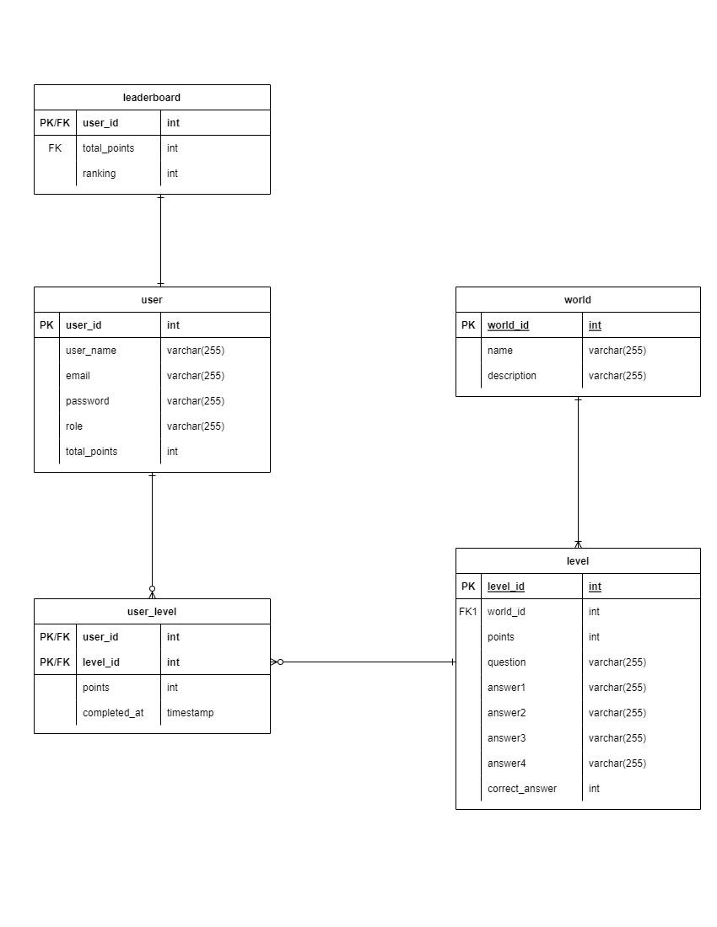

**Note: A high resolution version of these diagrams can be found in our SVN submission.**